LAB Logbook

Lab 1
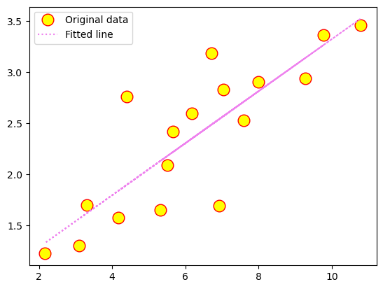
Lab 2
Test Accuracy: 0.901

Model: "sequential_1"
_________________________________________________________________
Layer (type) Output Shape Param #
=================================================================
dense_4 (Dense) (None, 64) 704

dense_5 (Dense) (None, 32) 2080

dense_6 (Dense) (None, 1) 33

=================================================================
Total params: 2817 (11.00 KB)
Trainable params: 2817 (11.00 KB)
Non-trainable params: 0 (0.00 Byte)
_________________________________________________________________
None
Model: "sequential_1"
_________________________________________________________________
Layer (type) Output Shape Param #
=================================================================
dense_4 (Dense) (None, 64) 704

dense_5 (Dense) (None, 32) 2080

dense_6 (Dense) (None, 1) 33

=================================================================
Total params: 2817 (11.00 KB)
Trainable params: 2817 (11.00 KB)
Non-trainable params: 0 (0.00 Byte)
_________________________________________________________________
None

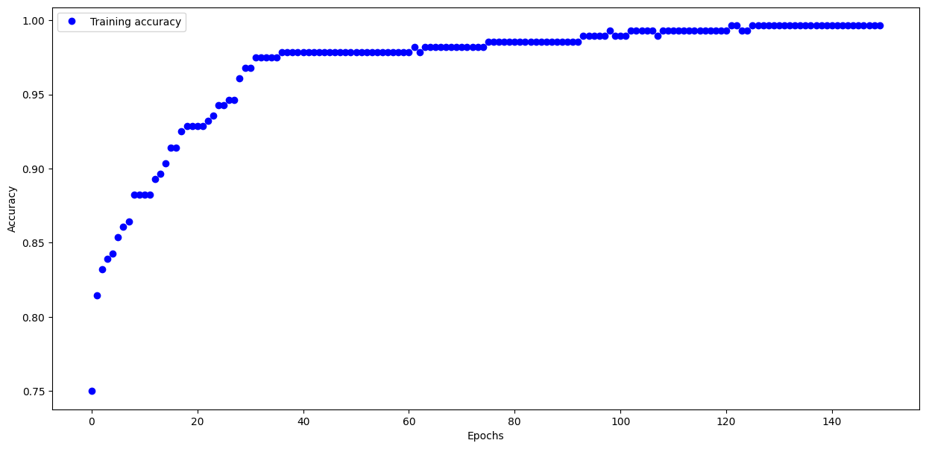
Task 2 :
O1 : 0.823
O2 : 0.823

Lab 3
Task 1:
313/313 - 0s - loss: 0.3622 - accuracy: 0.8799 - 211ms/epoch - 673us/step

Test accuracy: 0.8798999786376953

Task 2:
Model: "sequential"
_________________________________________________________________
Layer (type) Output Shape Param #
=================================================================
flatten (Flatten) (None, 784) 0

dense (Dense) (None, 69) 54165

dense_1 (Dense) (None, 96) 6720

dense_2 (Dense) (None, 129) 12513

dense_3 (Dense) (None, 229) 29770

dense_4 (Dense) (None, 329) 75670

dense_5 (Dense) (None, 12) 3960

=================================================================
Total params: 182798 (714.05 KB)
Trainable params: 182798 (714.05 KB)
Non-trainable params: 0 (0.00 Byte)
_________________________________________________________________

Lab 4
Task1: History of Losses after every Epoch
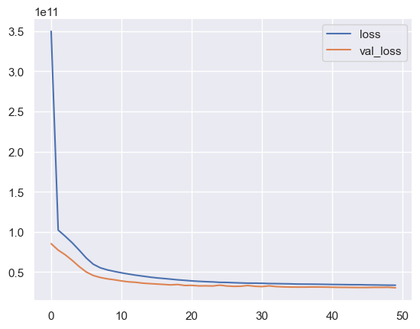
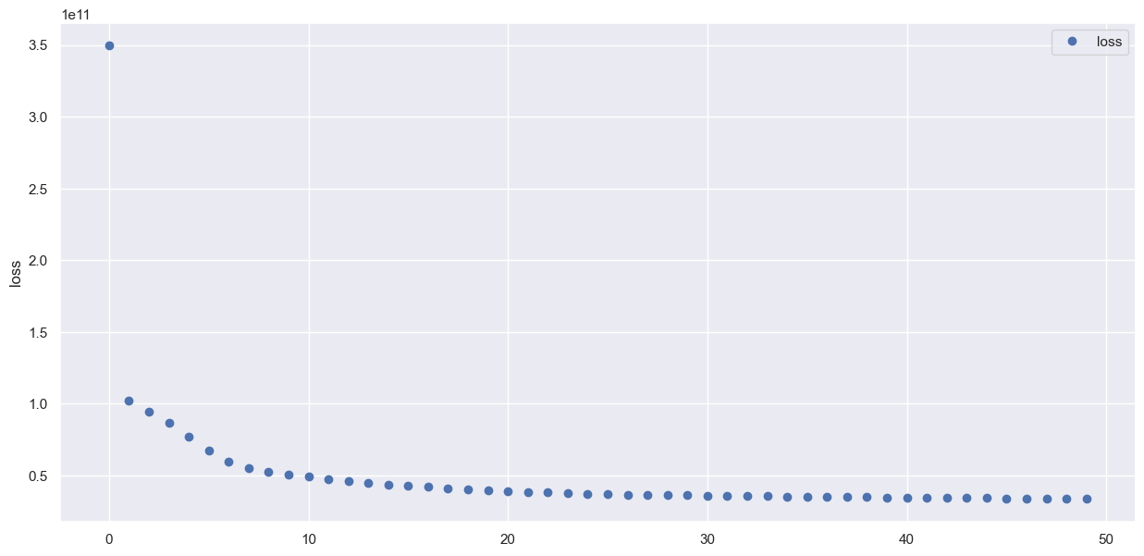

Task2: Model summary
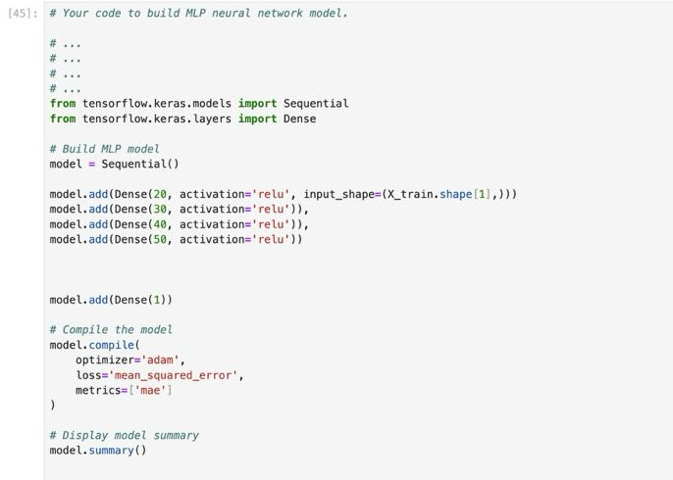

Model: "sequential"
_________________________________________________________________
Layer (type) Output Shape Param #
=================================================================
dense (Dense) (None, 20) 400

dense_1 (Dense) (None, 30) 630

dense_2 (Dense) (None, 40) 1240

dense_3 (Dense) (None, 50) 2050

dense_4 (Dense) (None, 1) 51

=================================================================
Total params: 4371 (17.07 KB)
Trainable params: 4371 (17.07 KB)
Non-trainable params: 0 (0.00 Byte)
_________________________________________________________________

Lab 5
Task1: Model building code and model summary.
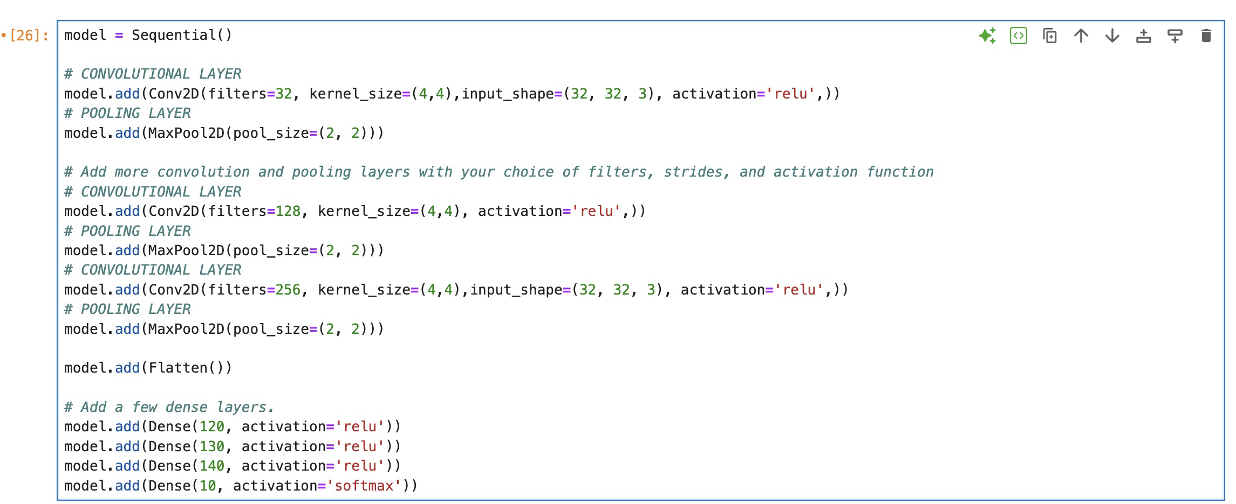
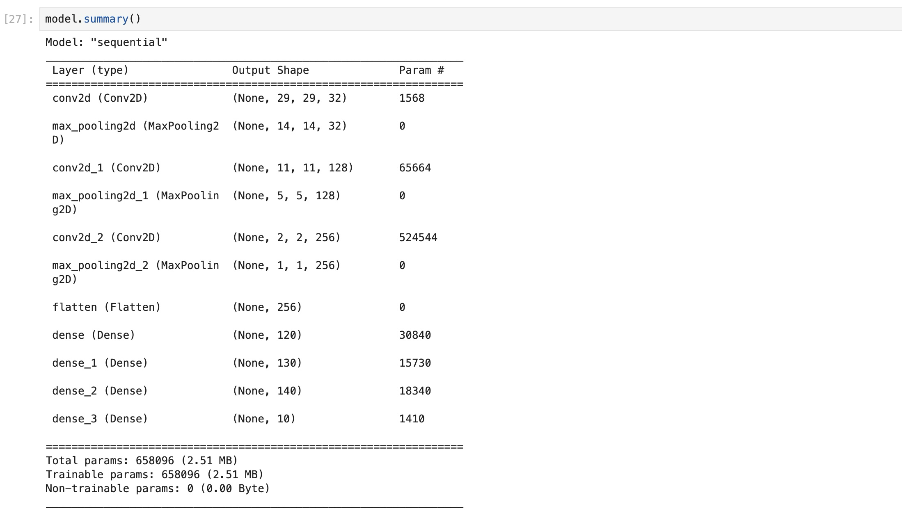

Task 2: Graphical representation depicting the train loss and validation loss trends (4 graphs)
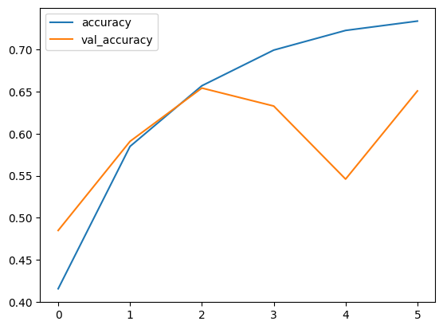

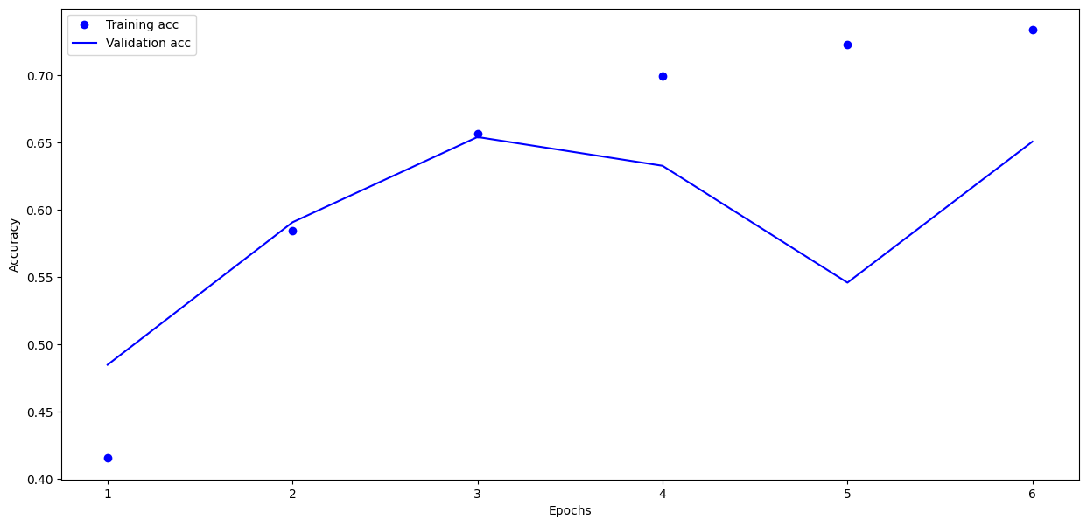



Lab 6
1.
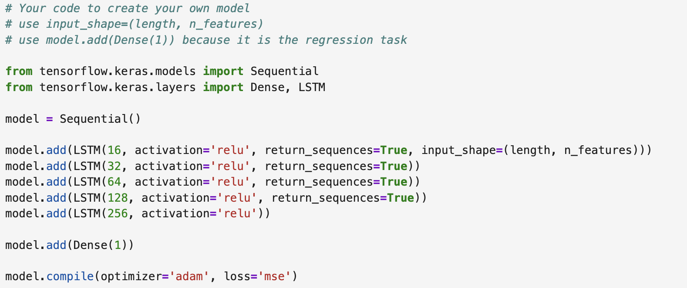

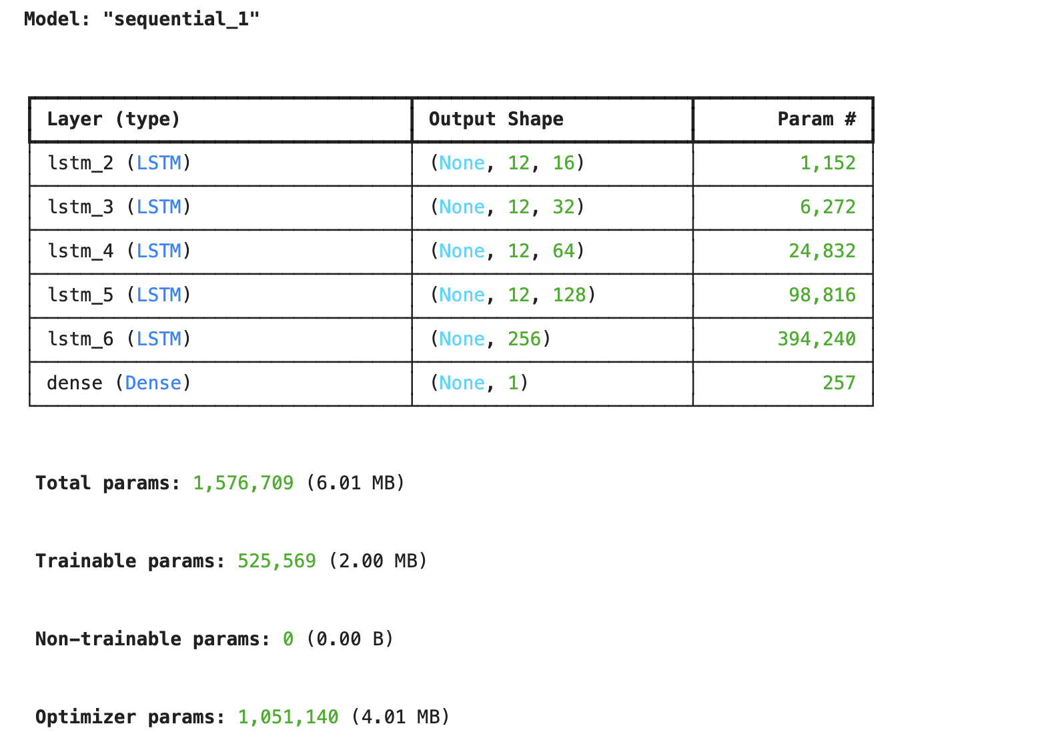
2.
early_stop = EarlyStopping(monitor='val_loss',patience=9)
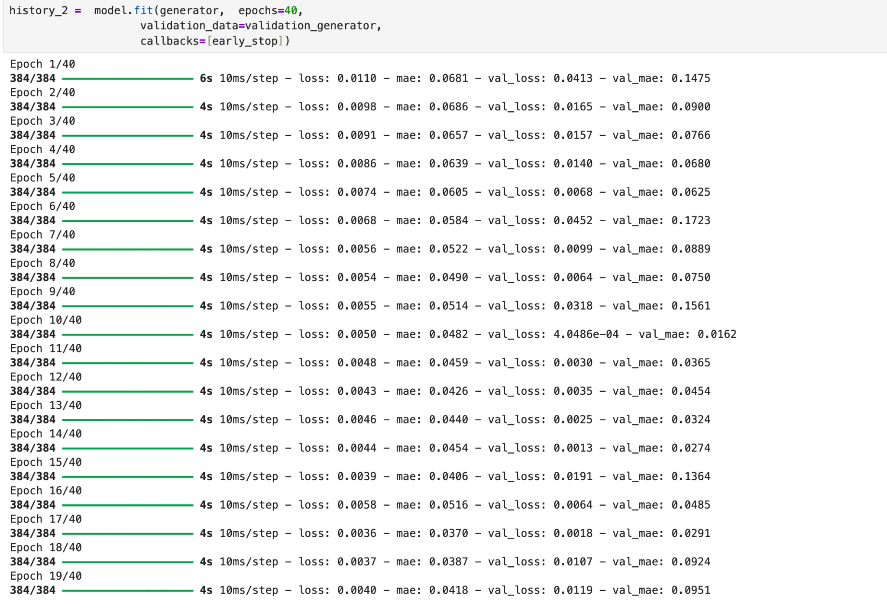
3. Plot of Validation
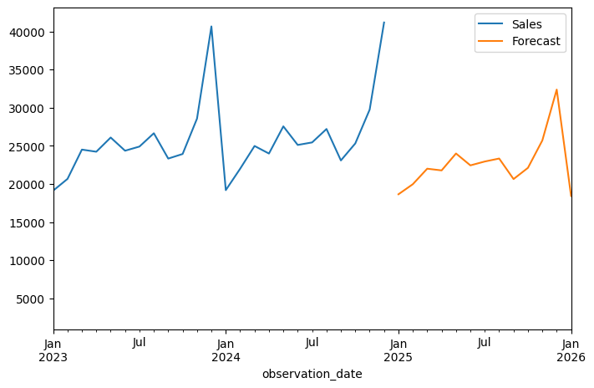
Test Loss
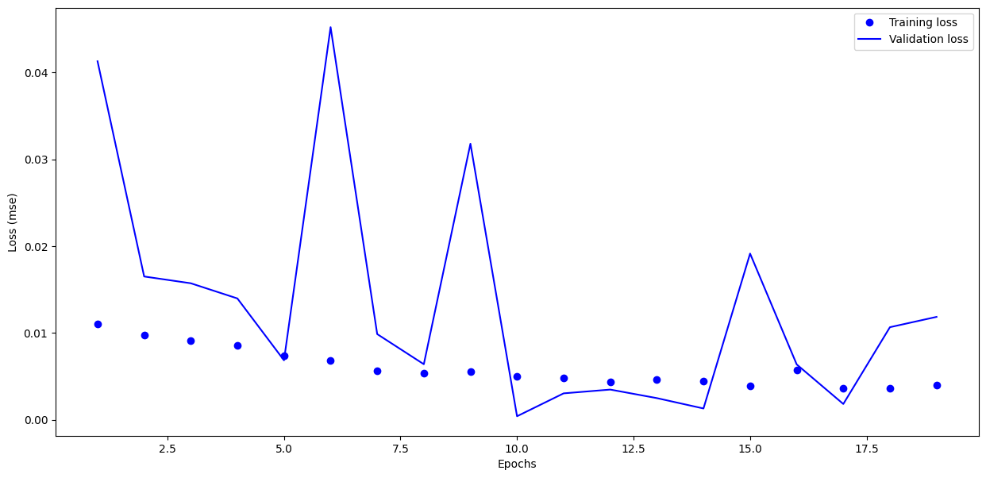
4. Optimal number of Epochs =10.
5.Plot of the Checking Forecast for the last 12 months.

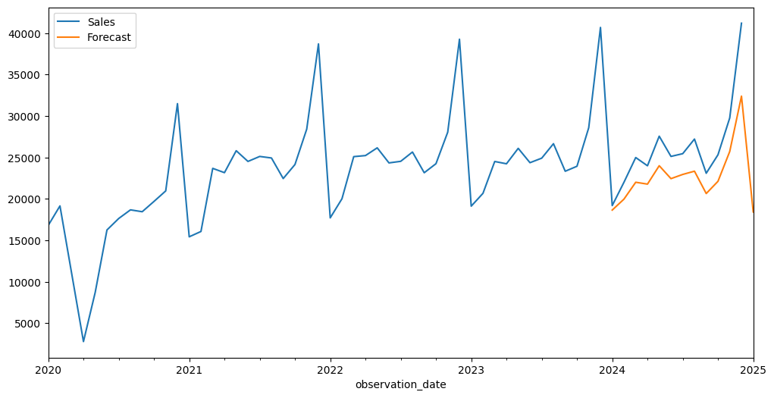

Lab 7

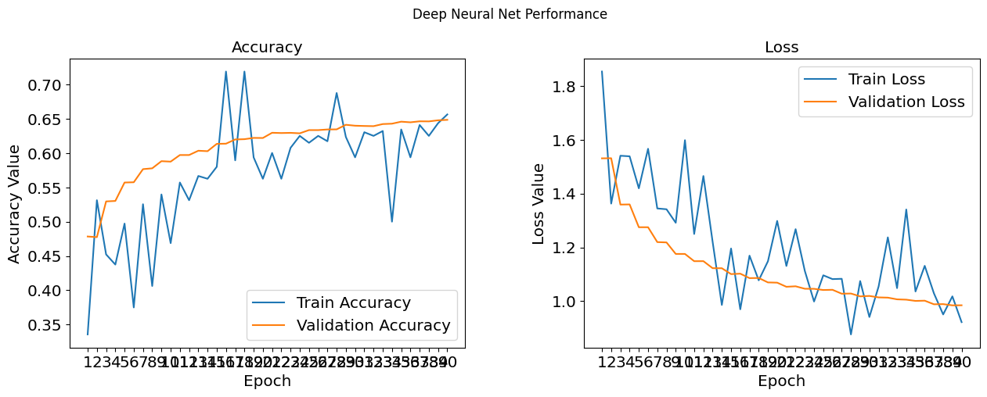

- 24

- early_stop = EarlyStopping(monitor='val_loss',patience=19)

- precision recall f1-score support
0 0.55 0.55 0.55 1000
1 0.56 0.59 0.58 1000
2 0.41 0.29 0.34 1000
3 0.35 0.33 0.34 1000
4 0.42 0.45 0.43 1000
5 0.44 0.37 0.40 1000
6 0.49 0.58 0.53 1000
7 0.51 0.59 0.54 1000
8 0.65 0.66 0.65 1000
9 0.55 0.58 0.56 1000
accuracy 0.50 10000
macro avg 0.49 0.50 0.49 10000
weighted avg 0.49 0.50 0.49 10000

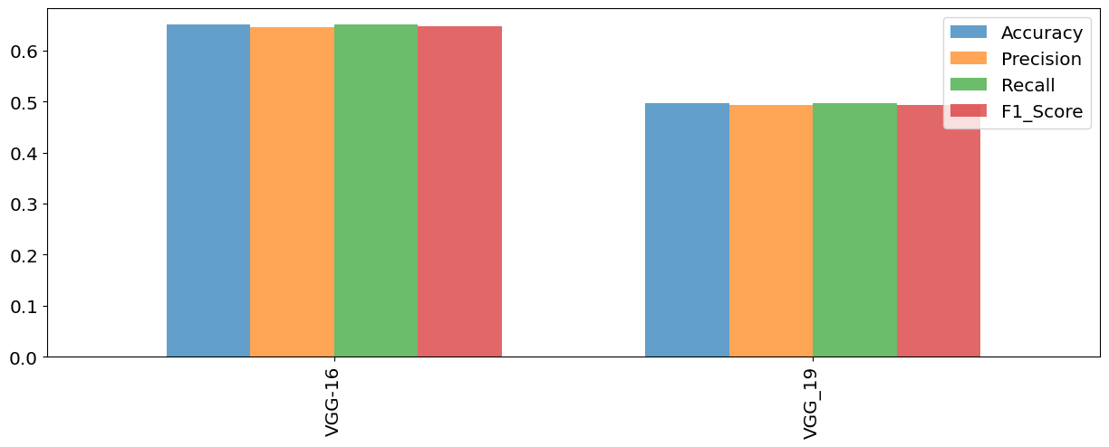

Lab 8
Model Summary
Model: "sequential"

┏━━━━━━━━━━━━━━━━━━━━━━━━━━━━━━━━━┳━━━━━━━━━━━━━━━━━━━━━━━━┳━━━━━━━━━━━━━━━┓
┃ Layer (type) ┃ Output Shape ┃ Param # ┃
┡━━━━━━━━━━━━━━━━━━━━━━━━━━━━━━━━━╇━━━━━━━━━━━━━━━━━━━━━━━━╇━━━━━━━━━━━━━━━┩
│ lstm (LSTM) │ (None, 100) │ 47,600 │
├─────────────────────────────────┼────────────────────────┼───────────────┤
│ dense (Dense) │ (None, 2) │ 202 │
└─────────────────────────────────┴────────────────────────┴───────────────┘

Total params: 47,802 (186.73 KB)

Trainable params: 47,802 (186.73 KB)

Non-trainable params: 0 (0.00 B)
None
model fit
history = model.fit(X_train, y_train, batch_size=20, epochs=20,
validation_split=0.1,
verbose=1, callbacks=[es, mc])

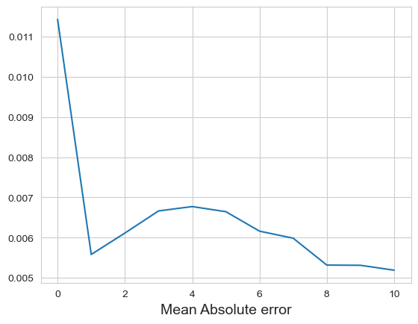
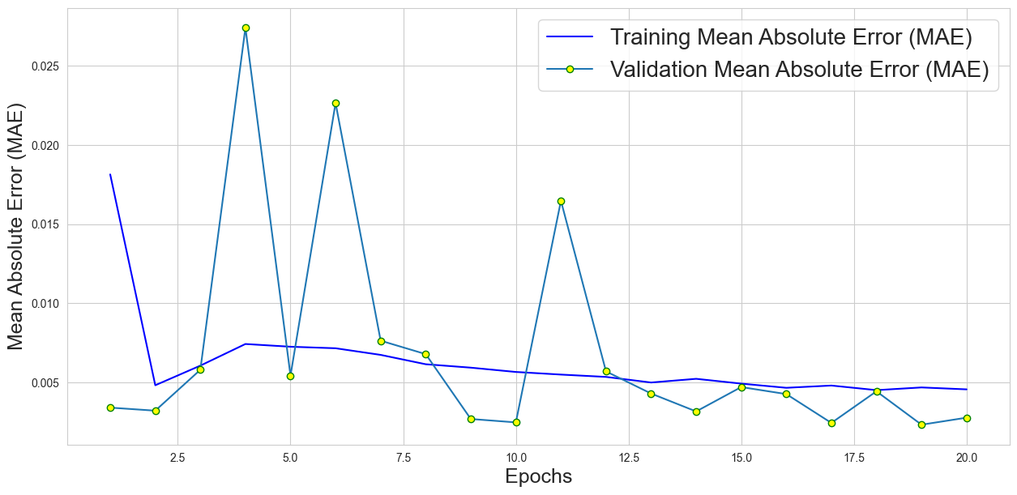

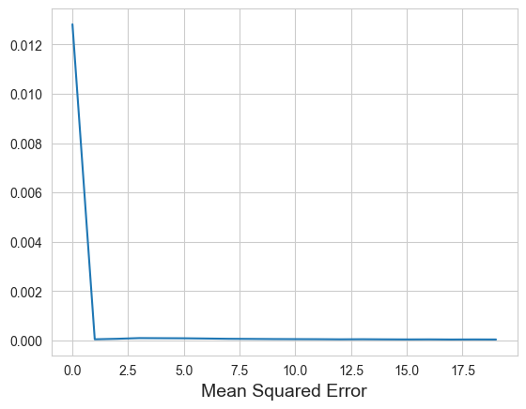
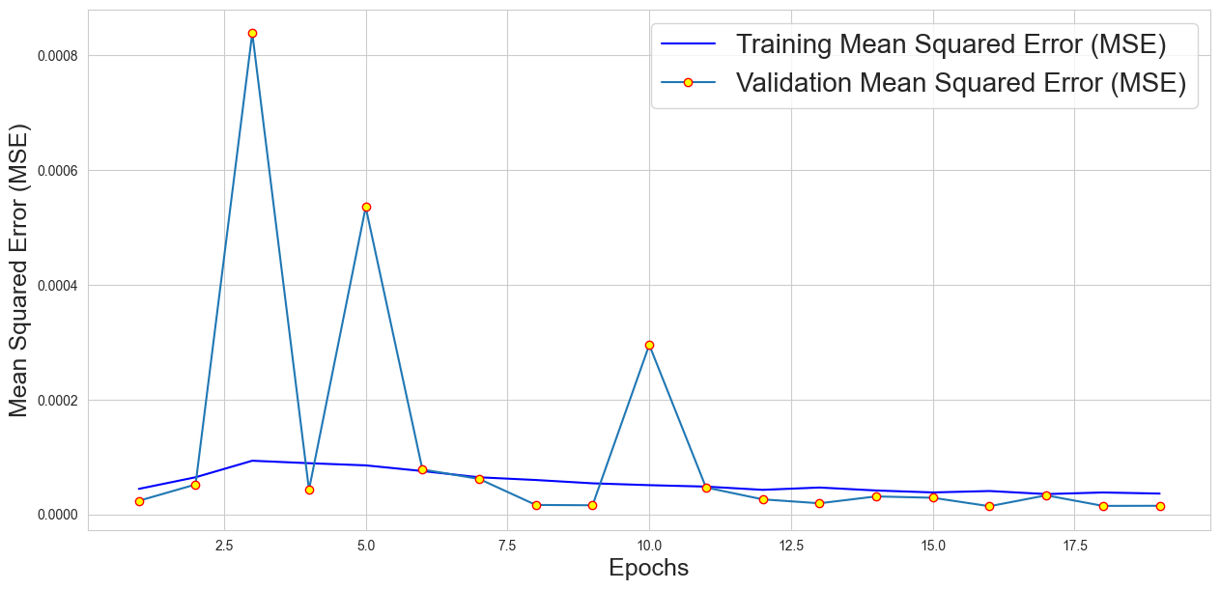
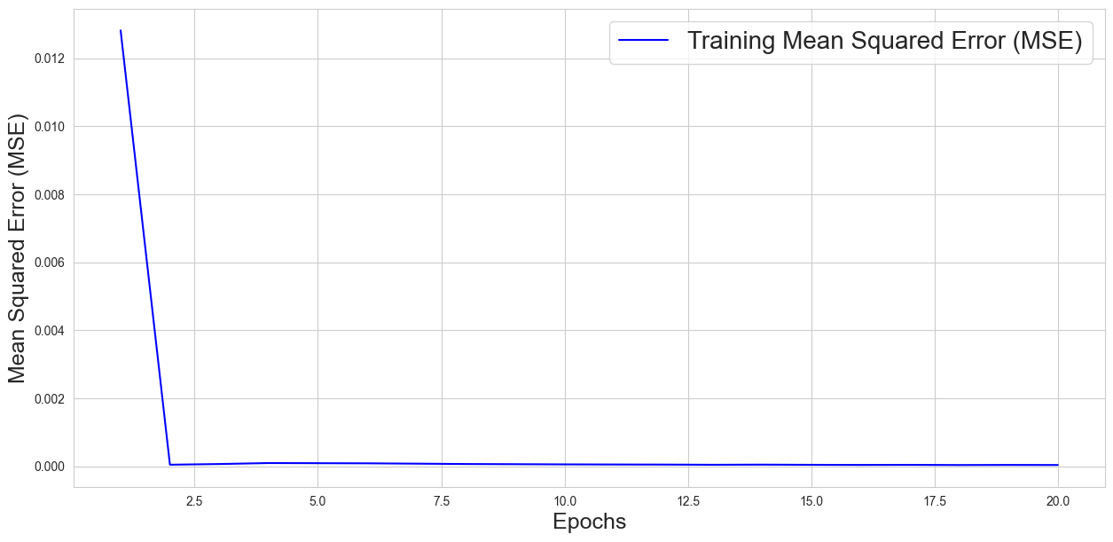

Lab 9
model checkpoint and early stopping code
es = EarlyStopping(monitor='val_loss', mode='min', patience=10, verbose=1)
mc = ModelCheckpoint('best_Trand-Flat_model_LSTM_GOLD.keras', monitor='val_loss', mode='min', verbose=1, save_best_only=True)

Code and training result
history = model.fit(X_train, y_train, batch_size=19, epochs=39,
validation_split=0.2, shuffle=True,
verbose=1, callbacks=[es, mc],
class_weight=class_weight_dict)

classification report
precision recall f1-score support

0.0 0.89 1.00 0.94 1058
1.0 0.00 0.00 0.00 137

accuracy 0.89 1195
macro avg 0.44 0.50 0.47 1195
weighted avg 0.78 0.89 0.83 1195

Accuracy detail graph
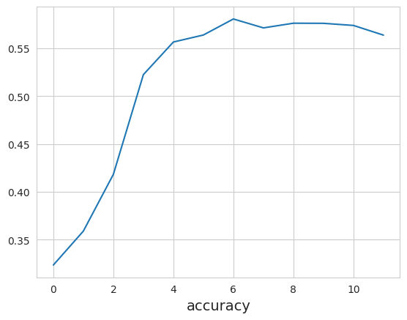

Lab 10
Task 1
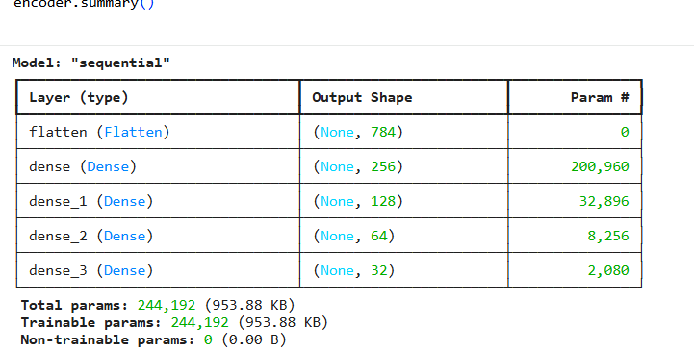
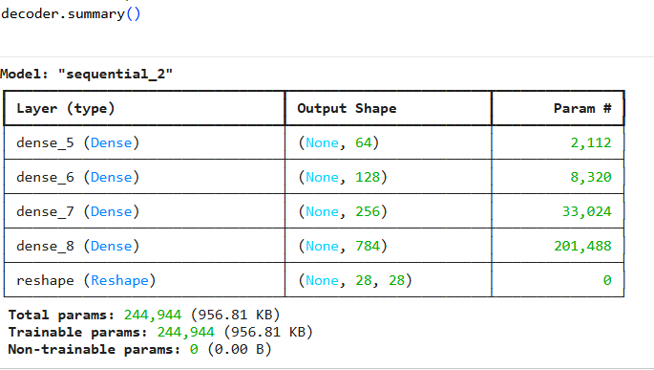
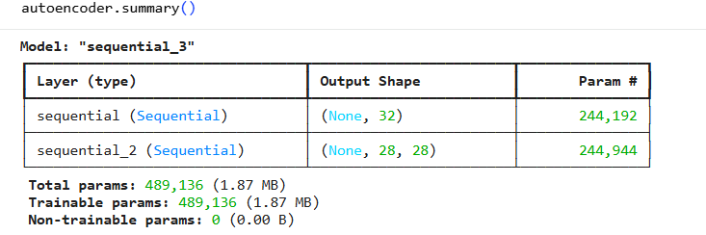
Task 2

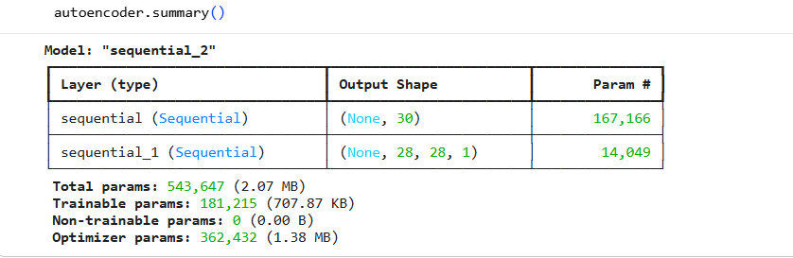
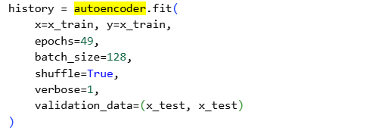
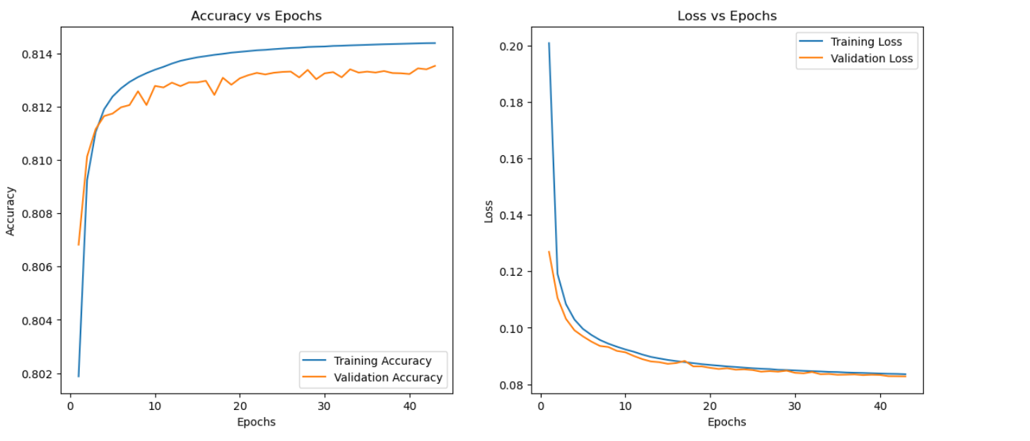
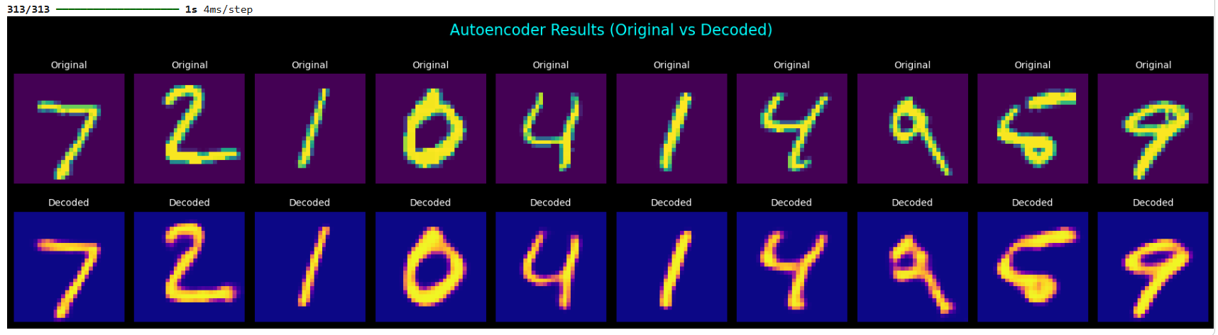

Lab 11
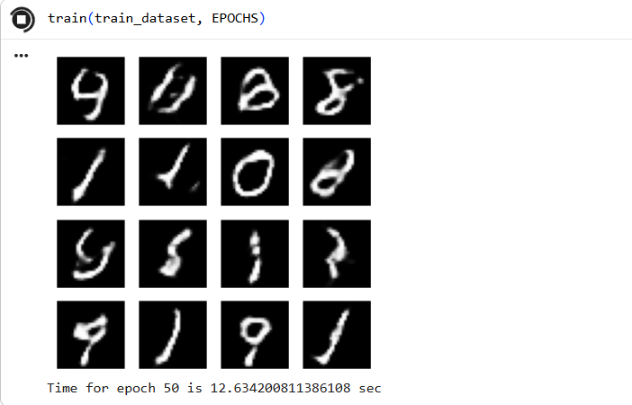
Lab 12

